Programming Coursework

Mohammed Khan

23670865

To start, make the players movable character:

Next, introduce movement to the sprite, the sprite is controlled by the player using the arrow keys:

After this, the first obstacle is introduced which is my second class, this will for currently be a rectangle for the time being, I have also added in a function so if it hits the edge of the screen, it will bounce off it:

Create array to store multiple obstacles of one class:

Next objective was to create the collision, with the player and the object and if there is a collision to delete the one that colluded with the player out the array, and to give response to the console:

Now that the class is made, I need a way to spawn it into the game, I didn’t want the obstacles to spawn to close to the player so I added a function which made it, so the obstacles don’t spawn within a safe radius, I also created a function which allows me to control the frequency of the obstacles spawned:

After making the first obstacle class, I want to make another, which will be faster than the first one, using inheritance, I have also added an image to this one rather than keeping it a shape, and will be doing so to my other objects:

Now I also must make the spawn function and collision function for the new obstacle class, which I copied and replaced the variable names where needed.:

New images being used:

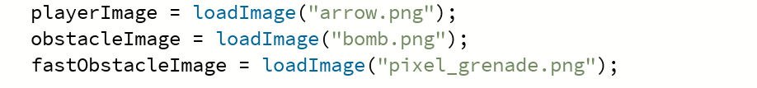

Now to create the illusion of the player moving, by shifting the obstacles:

Now, I want to add a lives function, where all lives are gone a game over screen is put up, to start I need to make a game over function and lives variable:



Now I must edit the draw function and change it so when obstacles collude it takes off a life, and when there are no lives the game over screen is displayed:

Now I wanted to make it so when the arrow keys are pressed the sprite, is facing the way that it is moving, to do this I must ensure that multiple key inputs are being taken in at once:

Within the player class:

